Barton Mills Resilience/disaster plan

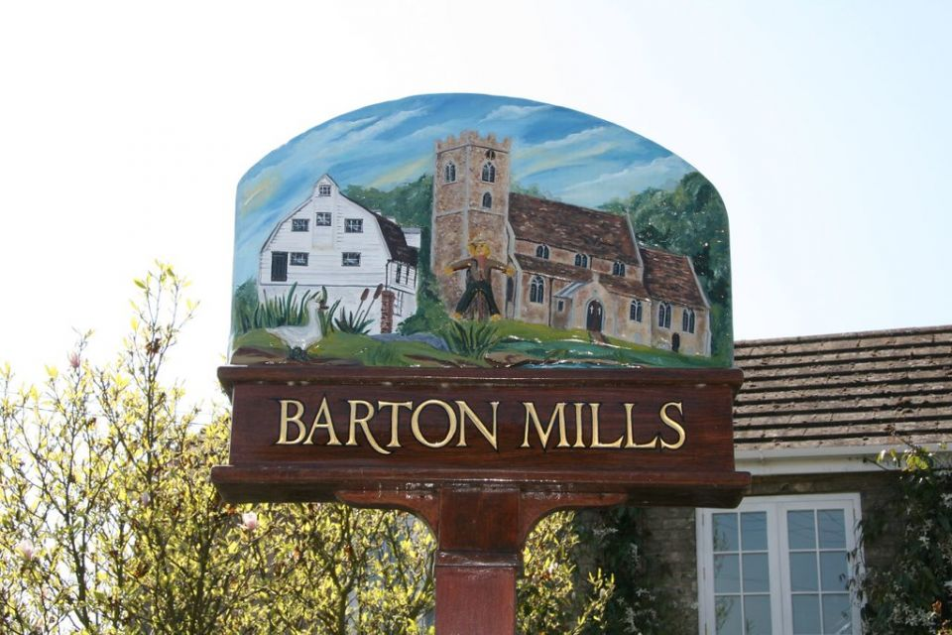

Barton Mills is a village in the West Suffolk district of Suffolk, England. The village is on the south bank of the River Lark. According to Eilert Ekwall the meaning of the village name is 'corn farm by the mill'.
The village was originally called Barton Parva (Little Barton). The name changed to Barton Mills in the eighteenth century.
The Domesday Book of 1086 records the population of the village in 1086 to be 22 households.^{[4]}
The village was once the holiday retreat for Alexander Fleming, the discoverer of penicillin, and there is a plaque on the wall outside his country home, The Dhoon, in the main street.
The village is near the Fiveways Roundabout, a busy junction where the A11 London to Norwich trunk road and Bury St. Edmunds roads meet.
The main settlement boundary centres around St Mary’s Church. Other settlements include new houses off the Worlington Road and across the other side of the A11 towards Tuddenham.

Suffolk Joint Emergency Planning Unit
The Suffolk Joint Emergency Planning Unit (JEPU) is a local authority partnership that supports the delivery of civil preparedness and business continuity services within the six local authorities in Suffolk. The Suffolk JEPU staff are based both in the districts and borough, and centrally with Suffolk County Council. This enables them to provide the subject matter expertise, planning, training and advice to officers and councillors to facilitate civil preparedness capability within each council. The JEPU also provides the local authority interface with the wider Suffolk Resilience Forum. Suffolk Resilience Forum Suffolk Resilience Forum is the principal mechanism for multi-agency cooperation under the Civil Contingencies Act 2004 and its boundaries are based on local policing boundaries. It is a multi-agency group that helps to coordinate activity in our county in planning, preparing, responding to, and recovering from major incidents. The aim of this guidance is to provide you with a starting point for the development of your plan. Examples shown in this guidance are drawn from national guidance or where we have seen good examples in existing Community Emergency Plans. JEPU can provide support in the development of your Community Emergency Plan, this is available by contacting your local Emergency Planning Officer (EPO).

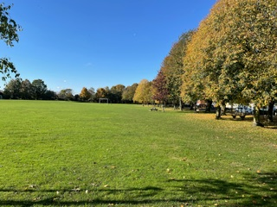

Aim
To enhance the resilience of Barton Mills through developing our local emergency preparedness, response and recovery arrangements which align with local responders and reduce the impact of the incident on our communities.

Objectives
- To understand our local risks/hazards
- To consider mitigation for the risks/hazards identified
- To assist our residents in being prepared for emergencies
- To identify and map our local resources and capabilities including volunteers
- To plan our local response arrangements to incidents
- To ensure we have effective communication mechanisms in place between emergency responders and the Parish Counciland our local communities.

Barton Mills
Barton Mills is a village and civil parish in the West Suffolk district of Suffolk, England. The village is on the south bank of the River Lark. The village is near the Fiveways Roundabout, a busy junction where the A11 London to Norwich trunk road, the A1065 towards North Norfolk and the A1101 (Long Sutton (Lincolnshire) to Bury St. Edmunds) roads meet. The village sits on the edge of Thetford Forest.
The settlement boundary is centred around St Mary’s Church with additional settlements off the Worlington Road to Mildenhall Road and on the other side off the A11 towards Tuddenham.
The US Airbases of Mildenhall and Lakenheath are nearby.

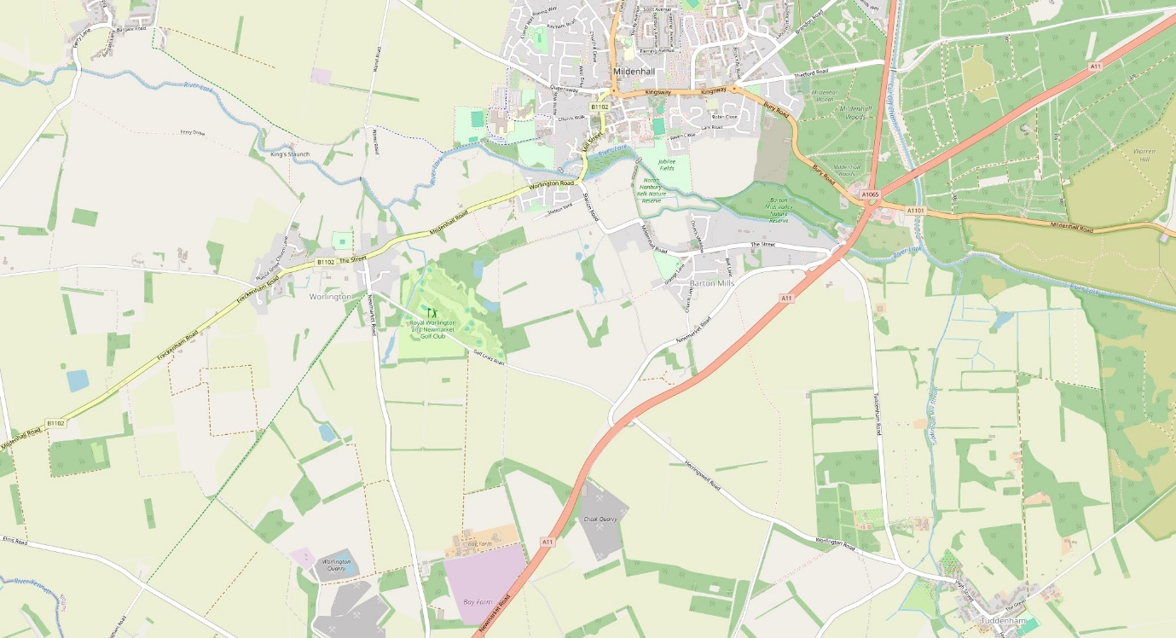

Risks
Barton Mills is a low crime area. The main risks of emergency will come from major traffic incidents on the A11; Severe weather including storms and flooding; crime/terrorism and local/national heath incidents.
The A11 passes through the village via the A11, going to or having passed the Fiveways island. There are passing gap for traffic to cross the A11 which are potentially hazardous.
The village is close to the river Lark. The water has broken the banks regularly, but some preventative steps have been taken such as the water meadow on the Norah Hanbury nature reserve.
The village is on the edge of Thetford Forest. Although this is far enough away to be a minimal risk, the village is very rural with plenty of trees which would add to the risk during a severe storm.
The risk of a crime or terror attack is exceptionally low due to the lack of industry, population, or strategic targets. However, the villages proximity to the US Airbases of Mildenhall and Lakenheath do add to the risk of terrorism and as a military target.
Cyber-attacks against bank or credit/debit card machines could leave local shops and businesses unable to make electronic money transfers. This would lead to cash only purchases or deferred payments until the issue is resolved.
Health issue such as the covid pandemic would be national but as previously, local support for those most vulnerable will be needed. The lack of heavy industry makes air born toxicity a minimal risk, but this level may increase when the solar farms are built In Worlington and Freckenham.

Council Emergency Planning Group
A small group of Barton Mills Parish Councillors (or agreed coopted members) should form the councils emergency planning group (CEPG). Three members including a lead will be required with a minimum 2 people able to declare an emergency situation.

Impact Assessment
The objective of this type of assessment is to determine whether there is a need to activate the plan, monitor the situation or remain in a ‘business-as-usual’ state.

METHANE
‘METHANE’ is the recognised common model for passing incident information between services and their control rooms. All local authority incident responders in Suffolk use the ‘METHANE’ model to capture information. The CEPG can use elements of this too to help collate the right information. Consider assessing the incident using the following:
M - Major incident Has a Major Incident been declared? This is not a question that CEPGs need to answer but is included for your awareness.
E - Exact Location What is the exact location or geographical area of incident? Use road names, post codes or grid references. What3Words would also be a good way to understand exactly where an incident is.
T - Type of Incident What kind of incident is it?
H - Hazards What hazards or potential hazards can be identified? What has caused the problem? How has it happened? Are there any secondary hazards to be considered?
A - Access What are the best routes for emergency services and responders for access and egress?
N - Number of casualties How many casualties are there and what condition are they in?
E - Emergency Services Which and how many emergency responder assets/personnel are required or are already on-scene? This is not a question that CEPGs need to answer but is included for your awareness

Activation
Community Emergency Plans may be activated as follows:
• Self-Activation by the CEPG, or for example, in response to a request from a member of the public or because of an event such as severe weather.
3 members should make up the group.
The Chairperson, Vice Chairperson and another member of the group or a coopted person from the village with appropriate skills. (Currently Elizabeth Jarvis)
Mick Colsey (Chairperson) 07715 982203
Ros Oke (Vice Chairperson) 07957 955773
Liz Jarvis 01638 583728
• A request from your Local Authority
If the local authority (West Suffolk District Council) agrees or requests the enactment of our emergency plan reasonable cost expenditure will be met by West Suffolk. The Local Authority public liability will only cover the CEPG for specific actions that they ask to be undertaken on their behalf, such as open a rest centre. When activated the exact task will be clearly defined but it will not cover for other activities the CEPG may undertake such as clearing roads/debris etc.

• A request from the Emergency Service
If a member of the emergency planning group calls an emergency situation, any action will be covered by the council's public liability cover.

Community Assets and Resources
As ever, the good people of Barton Mills will be its greatest asset in an emergency. However other resources are available in an emergency.
Buildings such as the village hall, church rooms and the 2 churches themselves can be used as a central hub, shelter, and/or overnight accommodation if necessary. Hotel chains including Travelodge (Fiveways Island) can offer free accommodation if available, in an emergency. They will also supply blankets if needed.
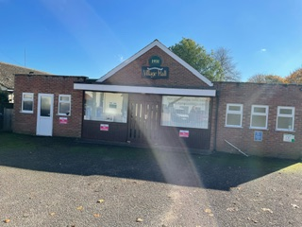

The two pubs in the village (The Bell and The Bull) will offer shelter, warmth, and nourishment.
Food can be obtained from supermarkets like Tesco’s who have national policy to provide food, water, and hygiene products in an emergency (Newmarket and Brandon). Sainsbury’s do not have a national policy but have said they would support local communities during emergencies. McDonalds also have a national policy to provide free food in and emergency (Fiveways Island). Food banks have become quite common in our towns and cities. The nearest food bank to Barton Mills is the Kings Project in Mildenhall. The Trussel Trust is a national food ban charity.
A ‘call to arms’ (Help) would best be achieved by using social media. The parish council’s own website would also be useful. The council has its own Facebook page, and the village has another page which is well used. The Next-door Neighbour site is also popular..
Royal Voluntary Services (RVS) can provide telephone support, shopping and medical prescription and small items of equipment delivery or collection service.
Various other charity support can be found locally by using the JOY website and referral platform.
There is a defibrillator in the phone box outside the Bell Pub in Bell Lane. You will need to ring 999 to obtain the code to access the defibrillator. Instructions on use are given once the defibrillator is opened.
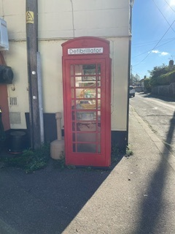

Useful Contacts
Police, Fire and Rescue and Ambulance 999

Kings Fund food bank
4 Kings St
Mildenhall
TEL 01638 428335
King's Church Mildenhall : King's Project
Find a food bank | Trussell

Joy platform Joy - The right support is just a few clicks away

Royal Voluntary Services NHS and Care Volunteer Responders | Supporting Health & Social Care (nhscarevolunteerresponders.org)

Age UK 0800 678 1602
Alcoholics Anonymous 0800 917 7650
CRUSE (Bereavement Support) 0800 808 1677
Men Advice 0808 801 0327
Debt Helpline 0800 808 4000
Relate 0300 003 0396
Shelter 0808 800 4444
SHOUT (Mental Health confidential text service) 85258
Women Advice 0808 200 0247
Samaritans freephone 116 123

Suffolk Lowland Search and Rescue – andy.king@sulsar.org.uk
Barton Mills Parish Council - clerk@bartonmills-pc.gov.uk

McDonalds Restaurant
Fiveways roundabout
01638 715041

Local Councillor - David Taylor
County Councillor – Louis Busuttil

West Suffolk Council - During office hours call 01284 763233 and request a call back from an Emergency Planning Officer. Out of hours call West Suffolk Council on 01284 763252 and request a call back from the Emergency Planning Officer.

