BARTON MILLS PARISH COUNCIL
INTERNAL CONTROL STATEMENT FOR YEAR ENDING 31 MARCH 2026

- SCOPE OF RESPONSIBILITY

Barton Mills Parish Council is responsible for ensuring that its business is conducted in accordance with the law and proper standards, and that public money is safeguarded and properly accounted for, and used economically, efficiently and effectively.

The council is responsible for ensuring that there is a sound system of internal control which facilitates the effective exercise of the Council’s functions, and which includes arrangements for the management of risk.

- THE PURPOSE OF THE SYSTEM OF INTERNAL CONTROL

The system of internal control is designed to manage risk to a reasonable level rather than to
eliminate all risk of failure to achieve policies, aims and objectives; it can therefore only provide
reasonable, and not absolute, assurance of effectiveness. The system of internal control is based on an on-going process designed to identify and prioritise the risks to the achievement of the Council’s policies, aims and objectives, to evaluate the likelihood of those risks being realised and the impact should they be realised, and to manage them efficiently, effectively and economically.

- THE INTERNAL CONTROL ENVIRONMENT

The Council:
The council reviews its obligations and objectives and approves budgets for the following year at its December or January meeting. The December or January meeting of the council approves the level of precept for the following financial year.

The Council has appointed a Finance Committee. The Committee meet at least once during the financial year. Members of the Committee monitor progress against objectives, financial systems and procedures, budgetary control and carry out regular reviews of financial matters. The minutes of the meetings of the Committee are circulated to all members of the Council.

The full council meets at least 11 times each year and monitors progress against its aims and objectives at each meeting by receiving relevant reports from the finance committee and parish clerk.

The council carries out regular reviews of its internal controls, systems and procedures. See attached Report.

Clerk to the Council/Responsible Finance Officer:
The Council has appointed a Clerk to the Council who acts as the Council’s advisor and administrator. The Clerk is the Council’s Responsible Financial Officer and is responsible for administering the Council’s finances. The Clerk is responsible for advising on the day to day compliance with laws and
regulations that the Council is subject to and for managing risks. The Clerk also provides advice to help the Council ensure that its procedures, control systems and policies are adhered to.

Payments:
All payments are reported to the council for approval. Two members of the council must sign every cheque or online authorisation. The signatories should consider each payment against the relevant invoice, either (a) sign the invoice and initial the cheque counterfoil or (b) review and authorise online. All authorised cheque signatories are members of the Council. Where delegation permits, as per s.101(1)(a) of the Local Government Act of 1972 and the Council’s Financial Regulations, a report will be provided to the next full Council.
The council normally make online payments. The payments will be approved at a full Parish Council meeting, the RFO will create the payments online and these will need to be approved by two members of the finance committee who will need to check the payments to the invoices.

Income:
All income is received and banked in the council’s name in a timely manner and reported to the council.

Risk Assessments/Risk Management:
The council reviews its risk assessment annually in May, and regularly reviews its systems and controls.

Internal Audit:
The council appoints an independent and competent internal auditor who reports to the council on a annual basis on the adequacy of it’s:

- Records
- Procedures
- Systems
- Internal control
- Regulations
- Risk management

External Audit:
The council’s external auditors, submit an annual certificate of audit which is presented to the
Council.

4. REVIEW OF EFFECTIVENESS

The council has responsibility for conducting an annual review of the effectiveness of the system of internal control, which should include a review of the effectiveness of internal audit. The results of that review must be considered by the Council, which should also approve the Statement of Internal Control.

-------------------------------- ----- -----------------------------------
Chairman RFO/Clerk

Approved and adopted by Barton Mills Parish Council

Meeting date:

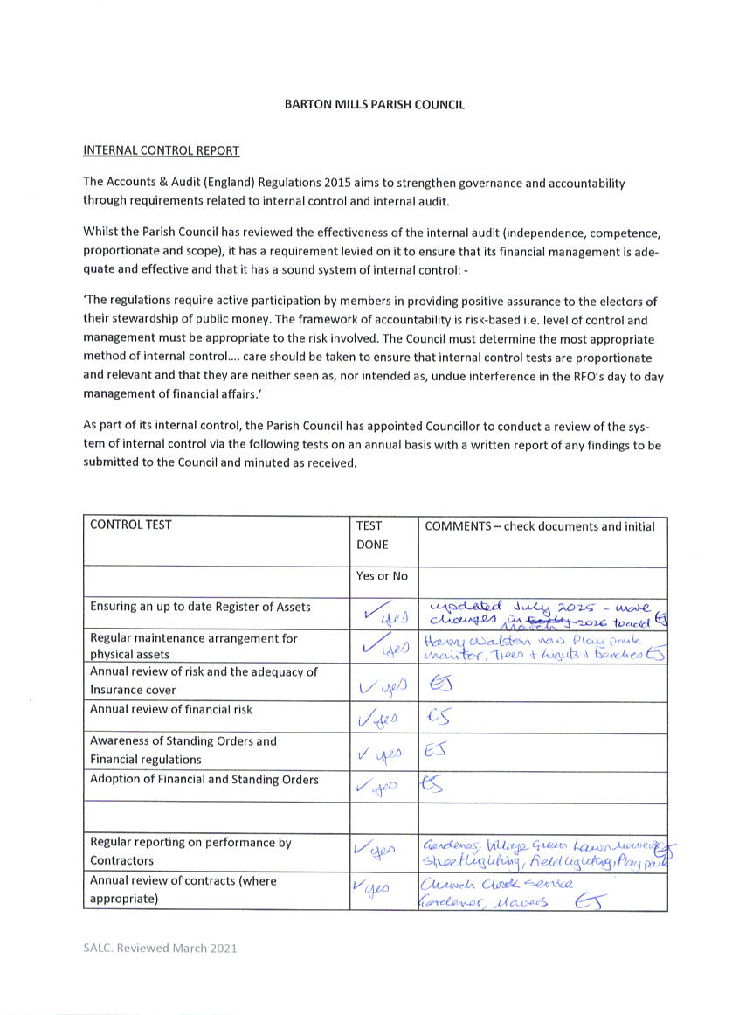
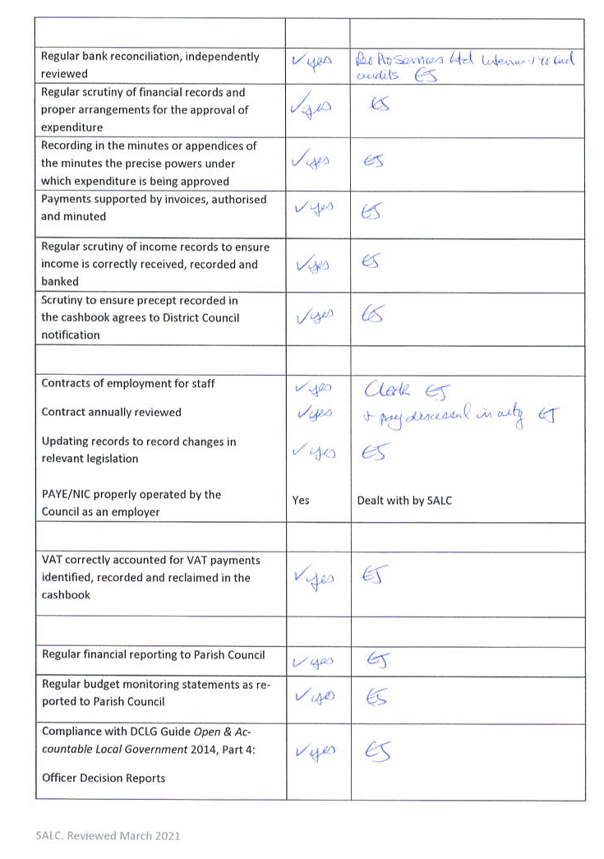
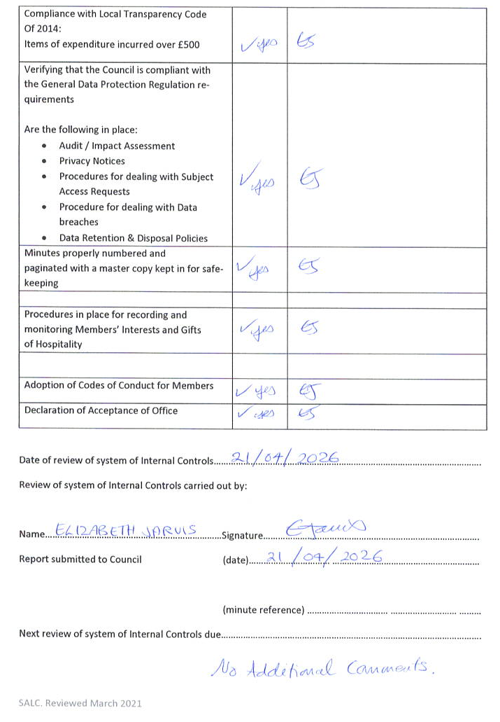
Additional comments by reviewer:

