Date: 21 March 2019

Second Road Closure Update

Burwell to Lakenheath Area Electricity Reinforcement scheme

As you may be aware, UK Power Networks are responsible for delivering the electricity to your local area and are in the process of installing approximately 25km of high voltage electricity cables as part of a reinforcement scheme between Burwell and Brandon Road, Lakenheath.

We are ahead of schedule and will therefore be moving on to the second section of our closures from 25th March 2019.

The closure will be from The Street, Freckenham, at the junction with Chippenham Road, to The Street, Worlington at the junction with Newmarket Road. Estimated end date is 25th May 2019.

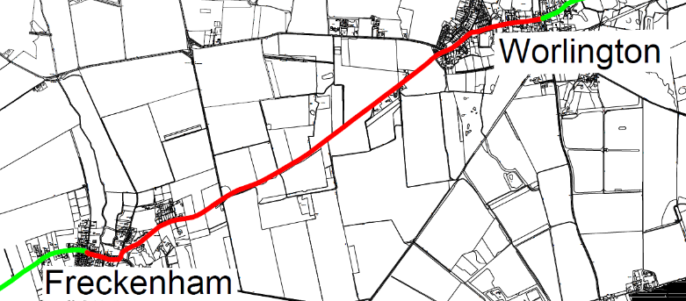
The closed section is shown below, diversion routes will be signed, with access to properties along the route being maintained.

Please note these dates may change based on performance.

We will send an update with estimated dates for the last section in due course.

Thank you for your patience and support during our works. We are doing everything possible to minimise any disruption during this work and apologise for any inconvenience caused.

If you would like any more information please do not hesitate to contact Valeria Colebrooke on 07827 239086. Additionally, you can contact our customer care team on 0800 028 4587 or care@ukpowernetworks.co.uk.

Yours Sincerely

Jonathan Ratsey
UK Power Networks Project Manager

